**Task 5 for submission**

*Part A addresses* ***Unit Objective 1 - Comprehend accounting concepts, principles and processes relating to accounting and end-of-month reporting for a service business.*** *The cognitive verbs,* ***describe*** *and* ***explain*** *are components of* ***comprehend*** *ie to show your comprehension of a concept, principle or process, you must describe or explain the concept, principle or process.*

**Part A**

In a 150 – 200 word paragraph, **explain** the steps to check an unbalanced trial balance.

The procedure to check and unbalanced trial balance are:

1.     Re-add the trial balance

2.     Check that each account has a balance of its ‘normal’ nature (DR or CR) – if it doesn’t, it could still be correct but is worth examining

3.     Compare the balance in each ledger account with the balance shown in the TB to check that each balance is listed and each balance is on the correct side with the correct amount

4.     Subtract the total debit from total credit and look for the difference (this might indicate a post has been omitted). Looking for half the difference may indicate a post has been put on the wrong side of the account and a difference divisible by 9 indicates a transposed figure (eg 649 instead of 946 or 54 instead of 45)

5.     Check the balance in each ledger account by re-adding the debits and credits and checking the subtraction to determine account balances

6.     Check all postings back to journals and source documents

*Parts B & C address* ***Unit Objective 3 - Analyse and interpret financial data and information relating to accounting and end-of month reporting for a service business.***

**Part B**

You are required to **analyse and interpret** the general ledger below to determine all transactions that have occurred during the month of February by:

1. describing the transaction;
2. interpreting the account rules that have been applied to each transaction.

The first transaction on 6 February has been completed for you below. There are a further four transactions (another on 6 Feb and also 15, 17 and 28 February).

*6 Feb Purchased supplies for cooking classes for cash $560.*

*Supplies is an asset increasing, therefore it is DR*

*Cash is an asset decreasing, therefore it is CR.*

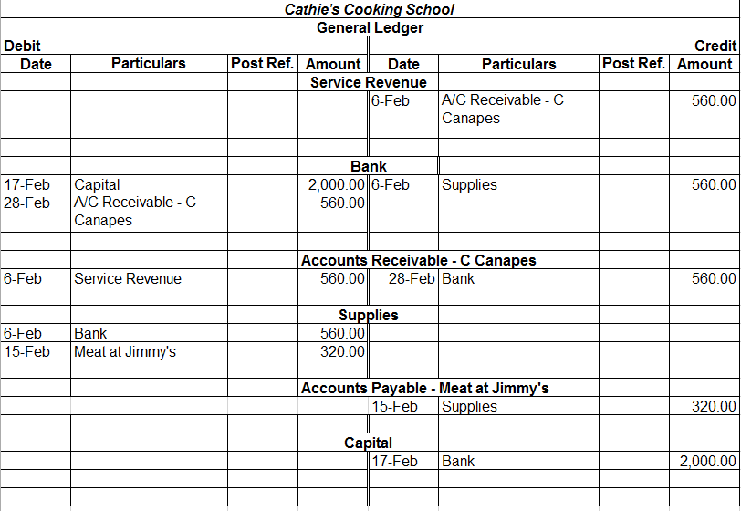

**6 Feb** Performed service on credit for C Canapes

Accounts receivable – C Canapes is asset increasing, therefore it is DR

Service revenue is revenue increasing, therefore CR

**15 Feb** Purchased supplies on credit from Meat at Jimmy’s for $320

Supplies is asset increasing, therefore it is DR

Accounts payable – Meat at Jimmy’s is a liability increasing, therefore it is CR

**17 Feb** Owner contributed $2000 cash to the business

Bank is an asset increasing, therefore it is DR

Capital is an Owner’s equity increasing, therefore it is CR

**28 Feb** Received cash from C Canapes (C Canapes settled their account)

Bank is an asset increasing, therefore it is DR

C Canapes is an asset decreasing, therefore it is CR

*Part C addresses* ***Unit Objective 2 - Apply accounting principles and processes relating to accounting and end-of-month reporting for a service business.***

**Part C**

You are required to **apply** accounting principles and processes for a service business to:

* process general journal entries for *All Clear Plumbing* to the columnar general ledger
* prepare a trial balance

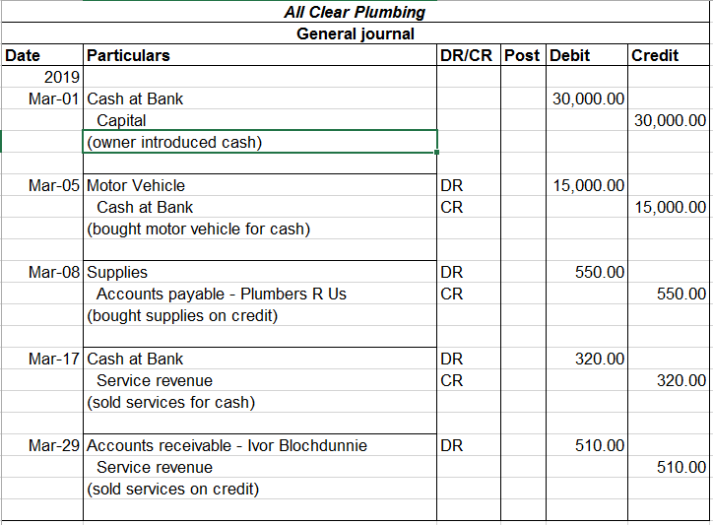

*Excel file